create database loan_info;

use loan_info;

CREATE TABLE Branch (

BranchName VARCHAR(30) PRIMARY KEY,

BranchCity VARCHAR(30),

Assets INT

);

-- Inserting values into Branch

INSERT INTO Branch VALUES

('SBI_Chamrajpet', 'Bangalore', 50000),

('SBI_ResidencyRoad', 'Bangalore', 10000),

('SBI_ShivajiRoad', 'Bombay', 20000),

('SBI_ParlimentRoad', 'Delhi', 10000),

('SBI_Jantarmantar', 'Delhi', 20000);

select * from Branch;

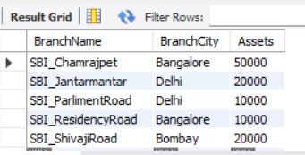

CREATE TABLE BankAccount (

AccNo INT PRIMARY KEY,

BranchName VARCHAR(30),

Balance INT,

FOREIGN KEY (BranchName) REFERENCES Branch(BranchName)

);

-- Inserting values into BankAccount

INSERT INTO BankAccount VALUES

(1, 'SBI_Chamrajpet', 2000),

(2, 'SBI_ResidencyRoad', 5000),

(3, 'SBI_ShivajiRoad', 6000),

(4, 'SBI_ParlimentRoad', 1000),

(5, 'SBI_Jantarmantar', 8000),

(6, 'SBI_ShivajiRoad', 4000),

(7, 'SBI_ResidencyRoad', 4000),

(8, 'SBI_ParlimentRoad', 3000),

(9, 'SBI_ResidencyRoad', 5000),

(10, 'SBI_ParlimentRoad', 3000),

(11, 'SBI_Jantarmantar', 2000);

select * from BankAccount;

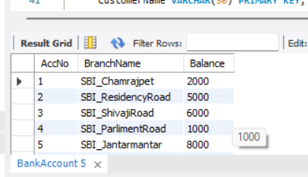

CREATE TABLE BankCustomer (

CustomerName VARCHAR(30) PRIMARY KEY,

CustomerStreet VARCHAR(50),

CustomerCity VARCHAR(30)

);

-- Inserting values into BankCustomer

INSERT INTO BankCustomer VALUES

('Avinash', 'Bull_Temple_Road', 'Bangalore'),

('Dinesh', 'Bannerghatta_Road', 'Bangalore'),

('Mohan', 'NationalCollege_Road', 'Bangalore'),

('Nikhil', 'Akbar_Road', 'Delhi'),

('Ravi', 'Prithviraj_Road', 'Delhi');

select * from BankCustomer;

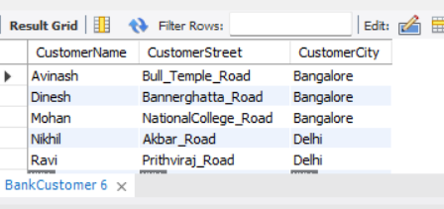

CREATE TABLE Deposit (

CustomerName VARCHAR(30),

AccNo INT,

FOREIGN KEY (CustomerName) REFERENCES BankCustomer(CustomerName),

FOREIGN KEY (AccNo) REFERENCES BankAccount(AccNo)

);

-- Inserting values into Deposit

INSERT INTO Deposit VALUES

('Avinash', 1),

('Dinesh', 2),

('Nikhil', 4),

('Ravi', 5),

('Avinash', 8),

('Nikhil', 9),

('Dinesh', 10),

('Nikhil', 11);

select * from Deposit;

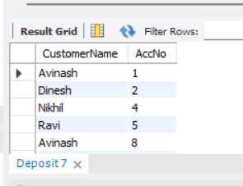

CREATE TABLE Loan (

LoanNumber INT PRIMARY KEY,

BranchName VARCHAR(30),

Amount INT,

FOREIGN KEY (BranchName) REFERENCES Branch(BranchName)

);

-- Inserting values into Loan

INSERT INTO Loan VALUES

(1, 'SBI_Chamrajpet', 1000),

(2, 'SBI_ResidencyRoad', 2000),

(3, 'SBI_ShivajiRoad', 3000),

(4, 'SBI_ParlimentRoad', 4000),

(5, 'SBI_Jantarmantar', 5000);

select * from loan;

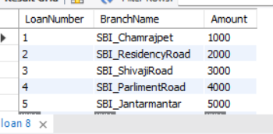

SELECT BranchName, assets / 100000 AS "assets in lakhs"

FROM Branch;



SELECT

d.CustomerName,

ba.BranchName

FROM

Deposit d

JOIN

BankAccount ba ON d.AccNo = ba.AccNo

GROUP BY

d.CustomerName, ba.BranchName

HAVING

COUNT(*) >= 1;



CREATE VIEW loan_info AS

SELECT BranchName, SUM(Amount) AS total_loan_amount

FROM Loan

GROUP BY BranchName;

SELECT * FROM loan_info;

